**WHAT IS AN IDE?**

An IDE, or Integrated Development Environment, enables programmers to consolidate the different aspects of writing a computer program.

IDEs increase programmer productivity by combining common activities of writing software into a single application: editing source code, building executables, and debugging.

## ADVANTAGES

The biggest benefit to using an IDE is that it allows you to code and run Java programs on your own computer

### EDITING SOURCE CODE

Writing code is an important part of programming. We start with a blank file, write a few lines of code, and thus a program can be created.IDEs facilitate this process with features like syntax highlighting and autocomplete.

#### SYNTAX HIGHLIGHTING

An IDE that knows the syntax of your language can provide visual cues. Keywords, words that have special meaning like class in Java, are highlighted with different colors.

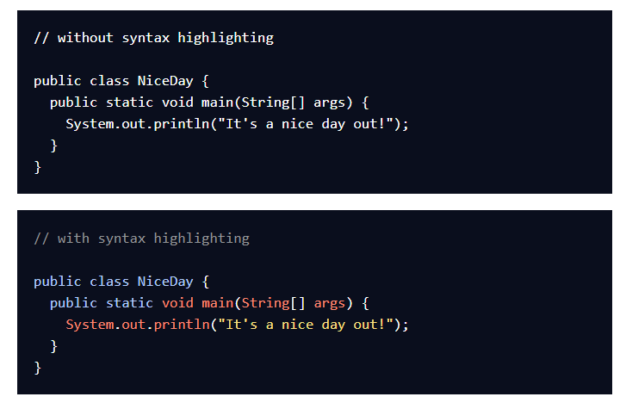

Syntax highlighting makes code easier to read by visually clarifying different elements of language syntax.

#### AUTOCOMPLETE

When the IDE knows your programming language, it can anticipate what you’re going to type next.

We’ve seen statements with System.out.println() quite a bit so far. In an IDE, we might see System as an autocomplete option after only typing Sy. This saves keystrokes so the programmer can focus on logic in their code.

### BUILDING EXECUTABLES

Java is a compiled language. Before programs run, the source code of a **.java** file must be transformed into an executable **.class** by the compiler. Once compiled, the program can be run from the terminal.

This compilation process is necessary for every program, so why not have the IDE do it for us? IDEs provide automated build processes for languages, so the act of compiling and executing code is abstracted away

### DEBUGGING

No programmer avoids writing bugs and programs with errors.

When a program does not run correctly, IDEs provide debugging tools that allow programmers to examine different variables and inspect their code in a deliberate way.

IDEs also provide hints while coding to prevent errors **before** compilation.

